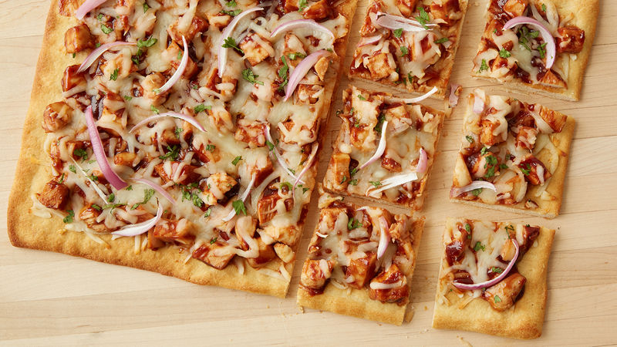
BBQ Chicken Pizza

Ingredients
1 can (13.8 oz) Pillsbury™ refrigerated thin pizza crust
2 cups coarsely chopped cooked chicken breast
¾ cup barbecue sauce
2 cups shredded mozzarella cheese (8 oz)
½ cup thinly sliced red onion
1 tbsp chopped fresh cilantro, if desired
Directions
- Heat oven to 400 degrees for dark or nonstick pan (425 degrees for all other pans). Spray 15x10x1-inch pan with cooking spray.
- Unroll dough in pan; starting at center, press dough into 15x10-inch rectangle. Bake 3 minutes.
- Meanwhile, in medium bowl, mix chicken and barbecue sauce until chicken is coated with sauce.
- Sprinkle 1 cup of the cheese over partially baked crust. Spoon and carefully spread chicken mixture evenly over cheese. Top with red onion and remaining 1 cup cheese.
- Rotate the pan 180 degrees and bake an additional 5 minutes.
- Sprinkle with cilantro. To serve, cut into 6 rows by 3 rows.

Note
Add Gorgonzola cheese

